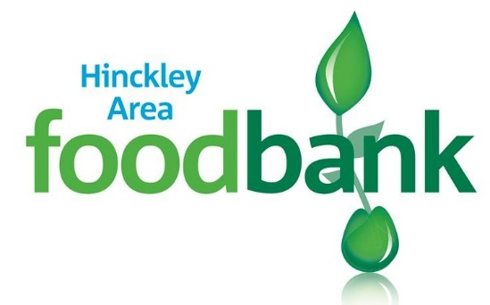

**01455 697 390**

[**info@hinckleyarea.foodbank.org.uk**](mailto:info@hinckleyarea.foodbank.org.uk)

**Easter eggs appeal**

Registered Charity Number: 1154754 | Registered in England & Wales

Help our food bank provide Easter eggs in the parcels we’ll be giving out this Easter.

Please bring all chocolates and Easter eggs to **any of our 9 centres** by **3rd April 2025**.

Thank you!