­­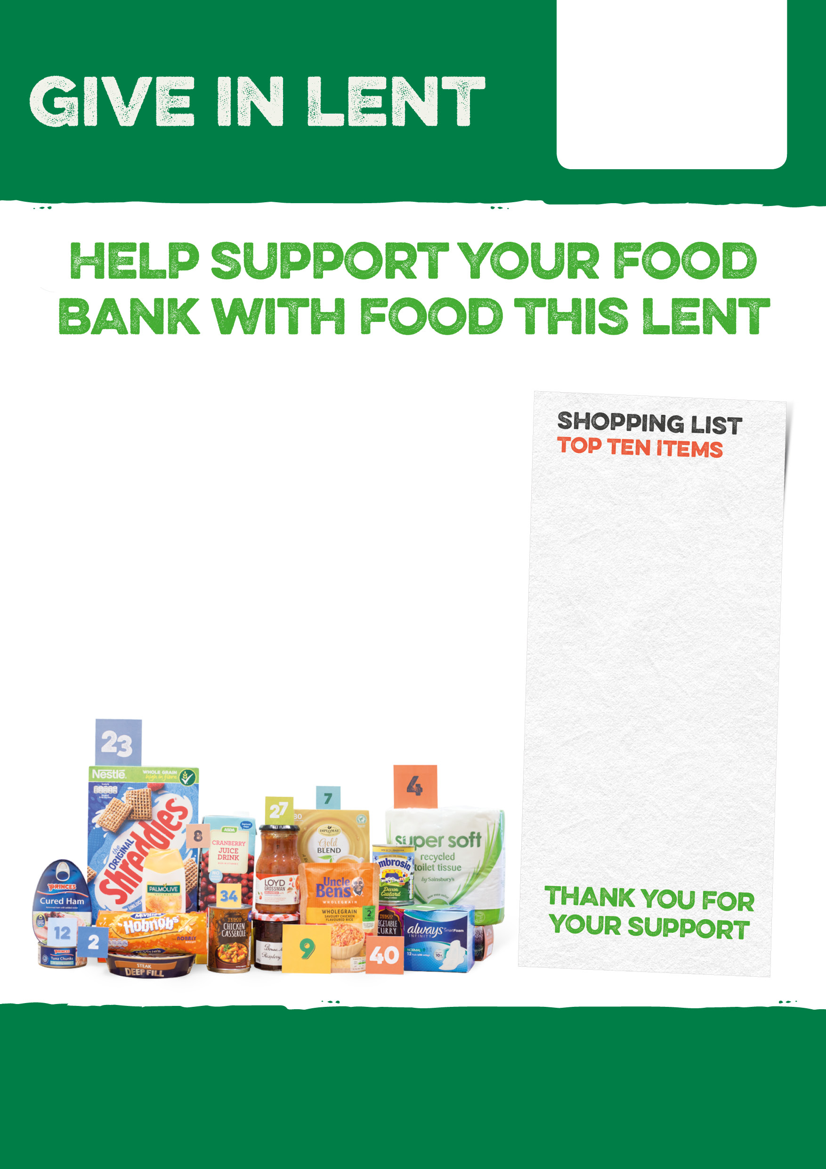

In the 6 weeks of Lent, the food bank will provide emergency food parcels for local people and families facing hardship.

The amount of help needed is outstripping the donations we’re receiving. Please donate an item or two from our shopping list, if you can.

**Shampoo**

**Tinned tomatoes**

**Veg cans <250g**

**Veg cans >399g**

**Tinned meat**

**Tinned fish**

**Fruit cans <326g**

**Fruit juice**

**UHD milk**

**Hot chocolate (made with water)**

To find out how to donate food visit

<https://hinckleyarea.foodbank.org.uk/>

Registered Charity in England & Wales (1154754)