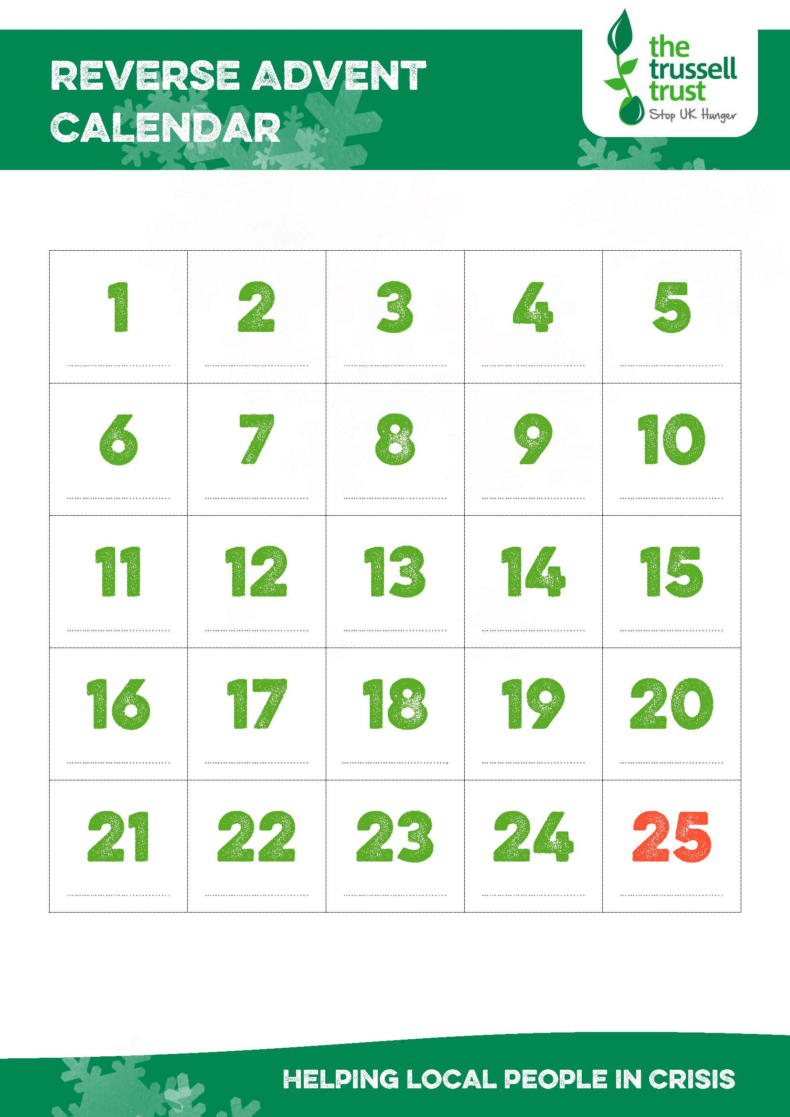

**Tinned fish**

**Dried milk**

**Chocolate bars**

**Tinned fruit fruit**

**UHTs**

**Squash**

**Tinned ham**

**Coffee 100g**

**Pasta or noodle snacks**

**Cake bars**

**UHT fruit juice**

**Small tins of fruit**

**Rice pudding**

**Womens toiletries**

**Mens toiletries**

**Jam**

**Washing powder (10 washes)**

**Instant hot chocolate**

**Tinned snacks**

**Instant mash potatoes**

**Large tinned meat**

**Simply donate an item for each day of Advent and donate it to the foodbank**

Below is a suggested list of items based on what is needed by Hinckley Area foodbank

**Large tinned veg**

**Sponge pudding**

**Tin openers**

**Biscuits**

**UHT milk**

**Supporting Hinckley Area foodbank**

**www.hinckleyarea.foodbank.org.uk**

Reg. Charity No. 1154754- Reg. in England & Wales