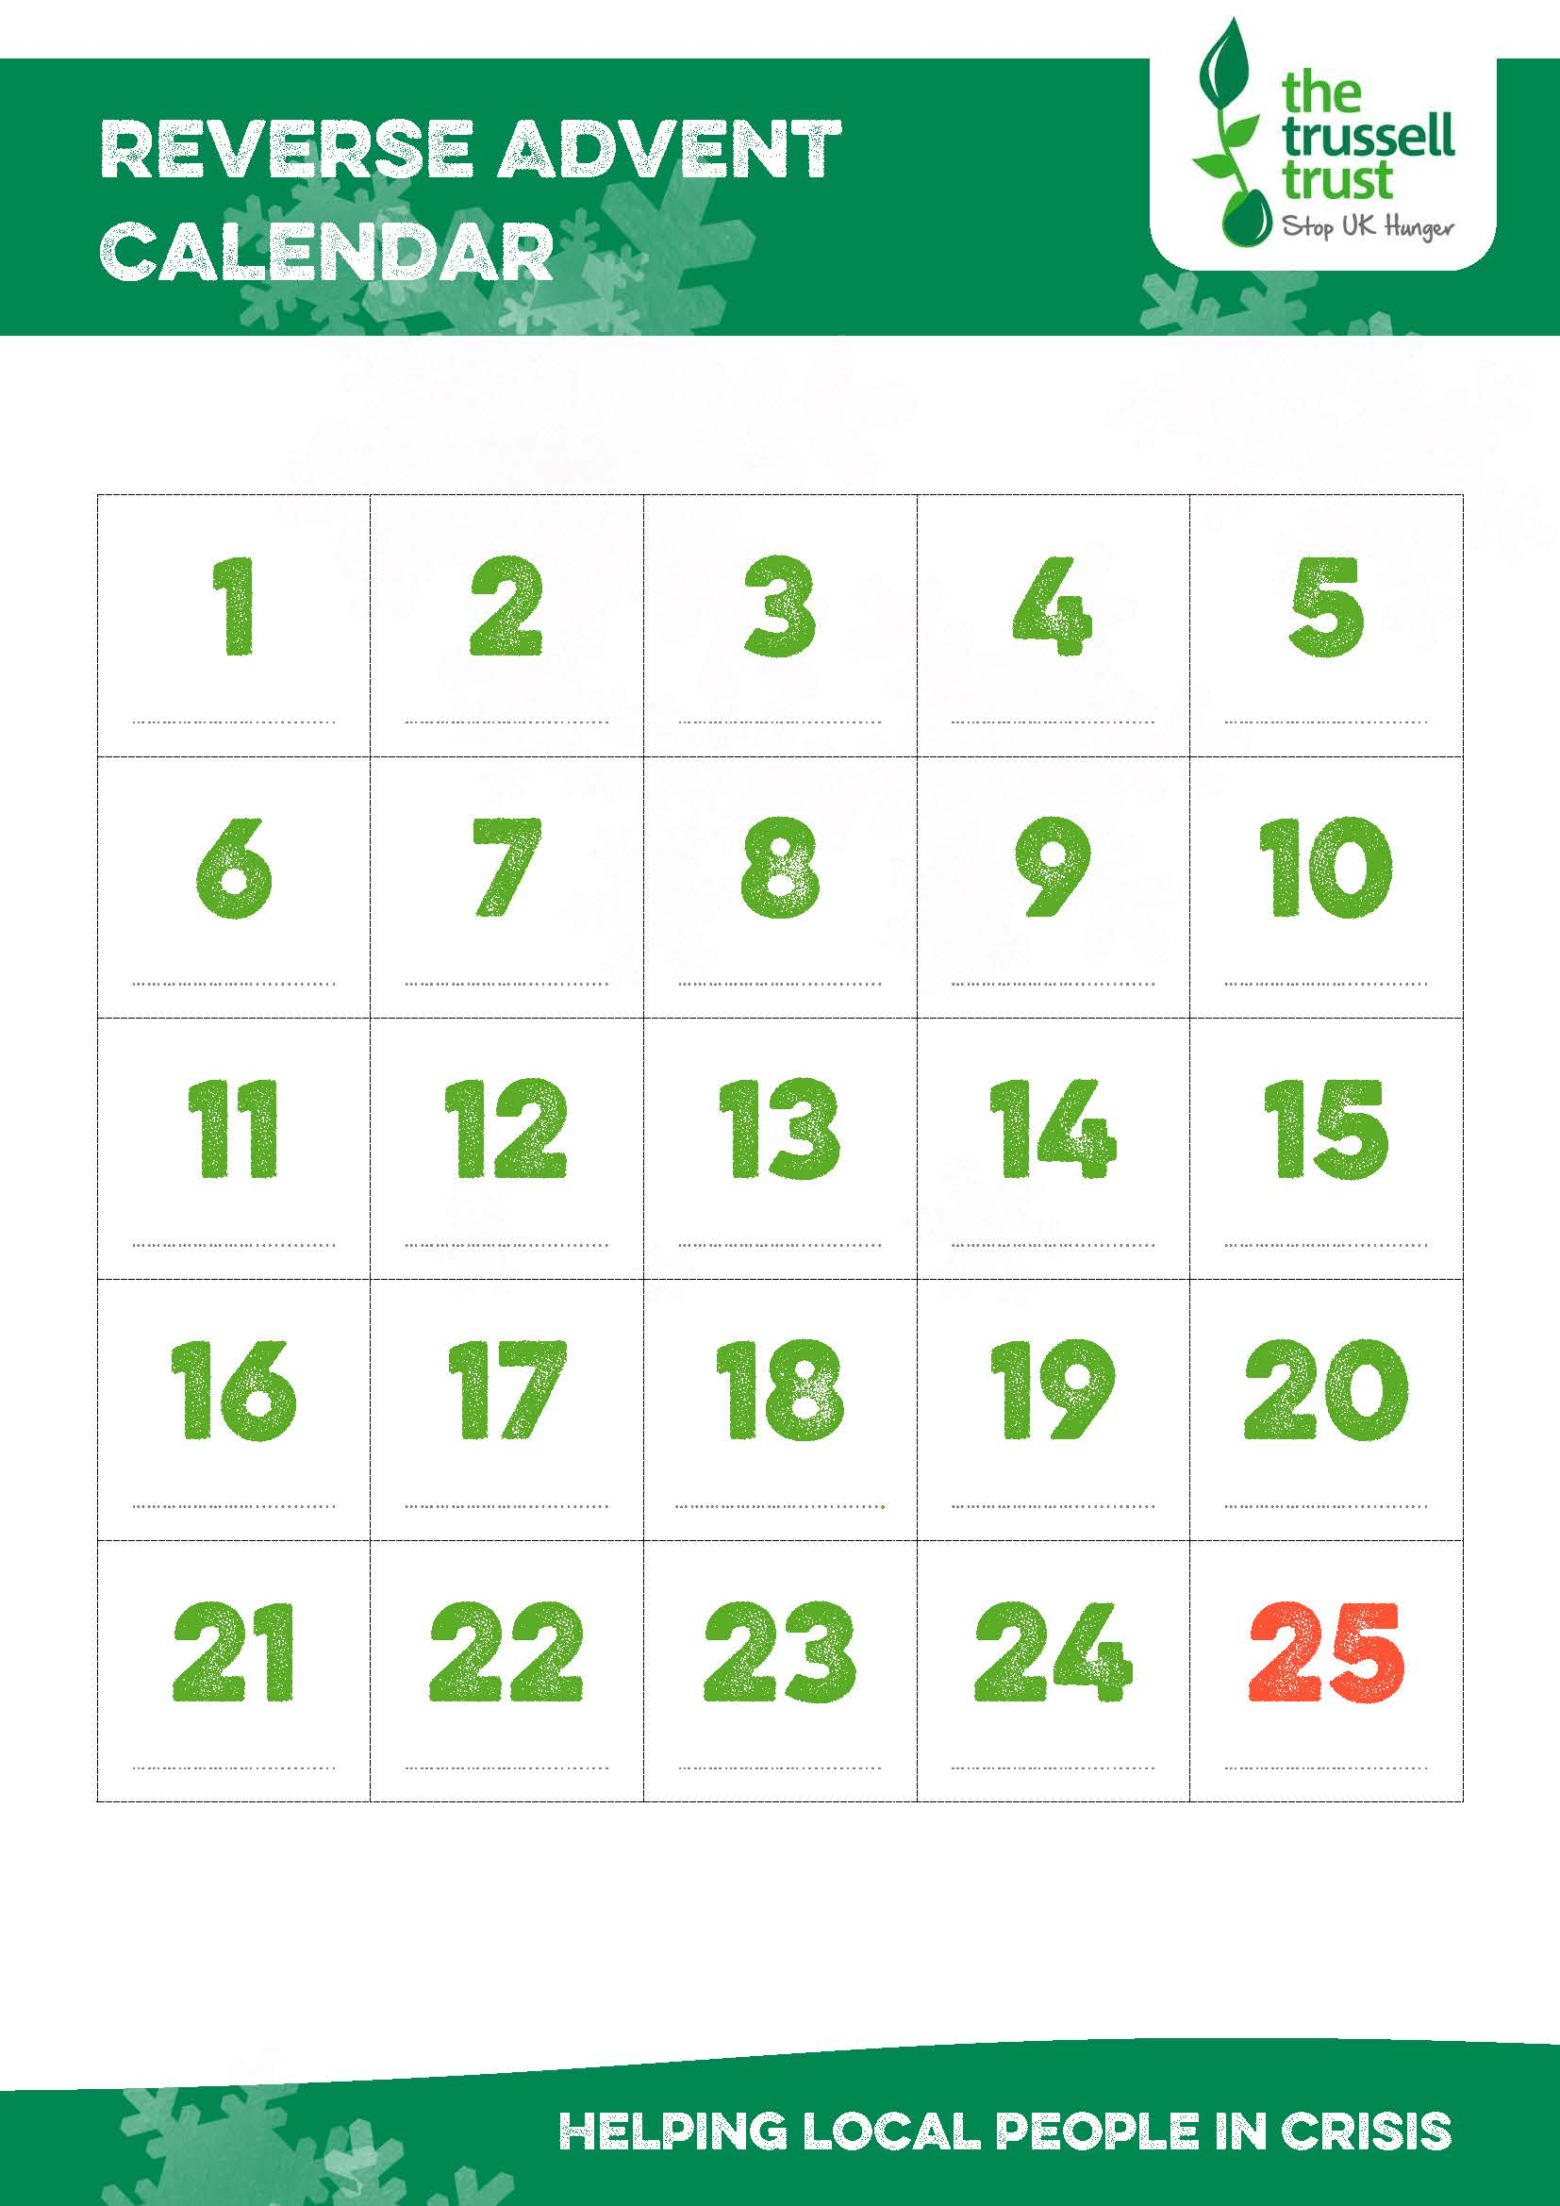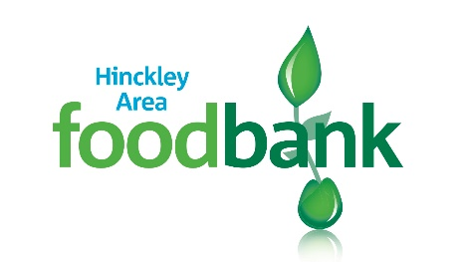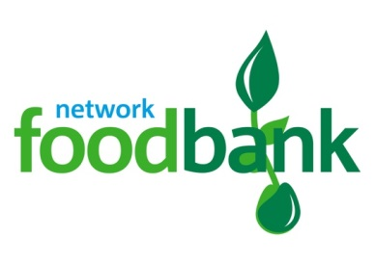

**Baby wipes**

**Childs toothbrush**

**Childrens toothpaste**

**Size 5 nappies**

**Size 6 nappies**

**Male shower gel**

**UHTs**

**Shampoo**

**Kitchen paper towels**

**Baby bath wash**

**Antibacterial wipes**

**Feminine hygiene tampons**

**Adult toothbrush**

**Disposable Razors**

**Toilet rolls**

**Washing powder (10 washes)**

**Male deodorant**

**Baby talc**

**Antibacterial spray**

**Hand wash**

**Adult toothpaste**

**Female deodorant**

**Simply donate an item for each day of Advent and donate it to the foodbank**

Below is a suggested list of items based on what is needed by Hinckley Area foodbank

**Washing up liquid**

**Shaving foam**

**Tin opener**

**Baby lotion**

**Supporting Hinckley Area foodbank**

**www.hinckleyarea.foodbank.org.uk**

Reg. Charity No. 1154754- Reg. in England & Wales