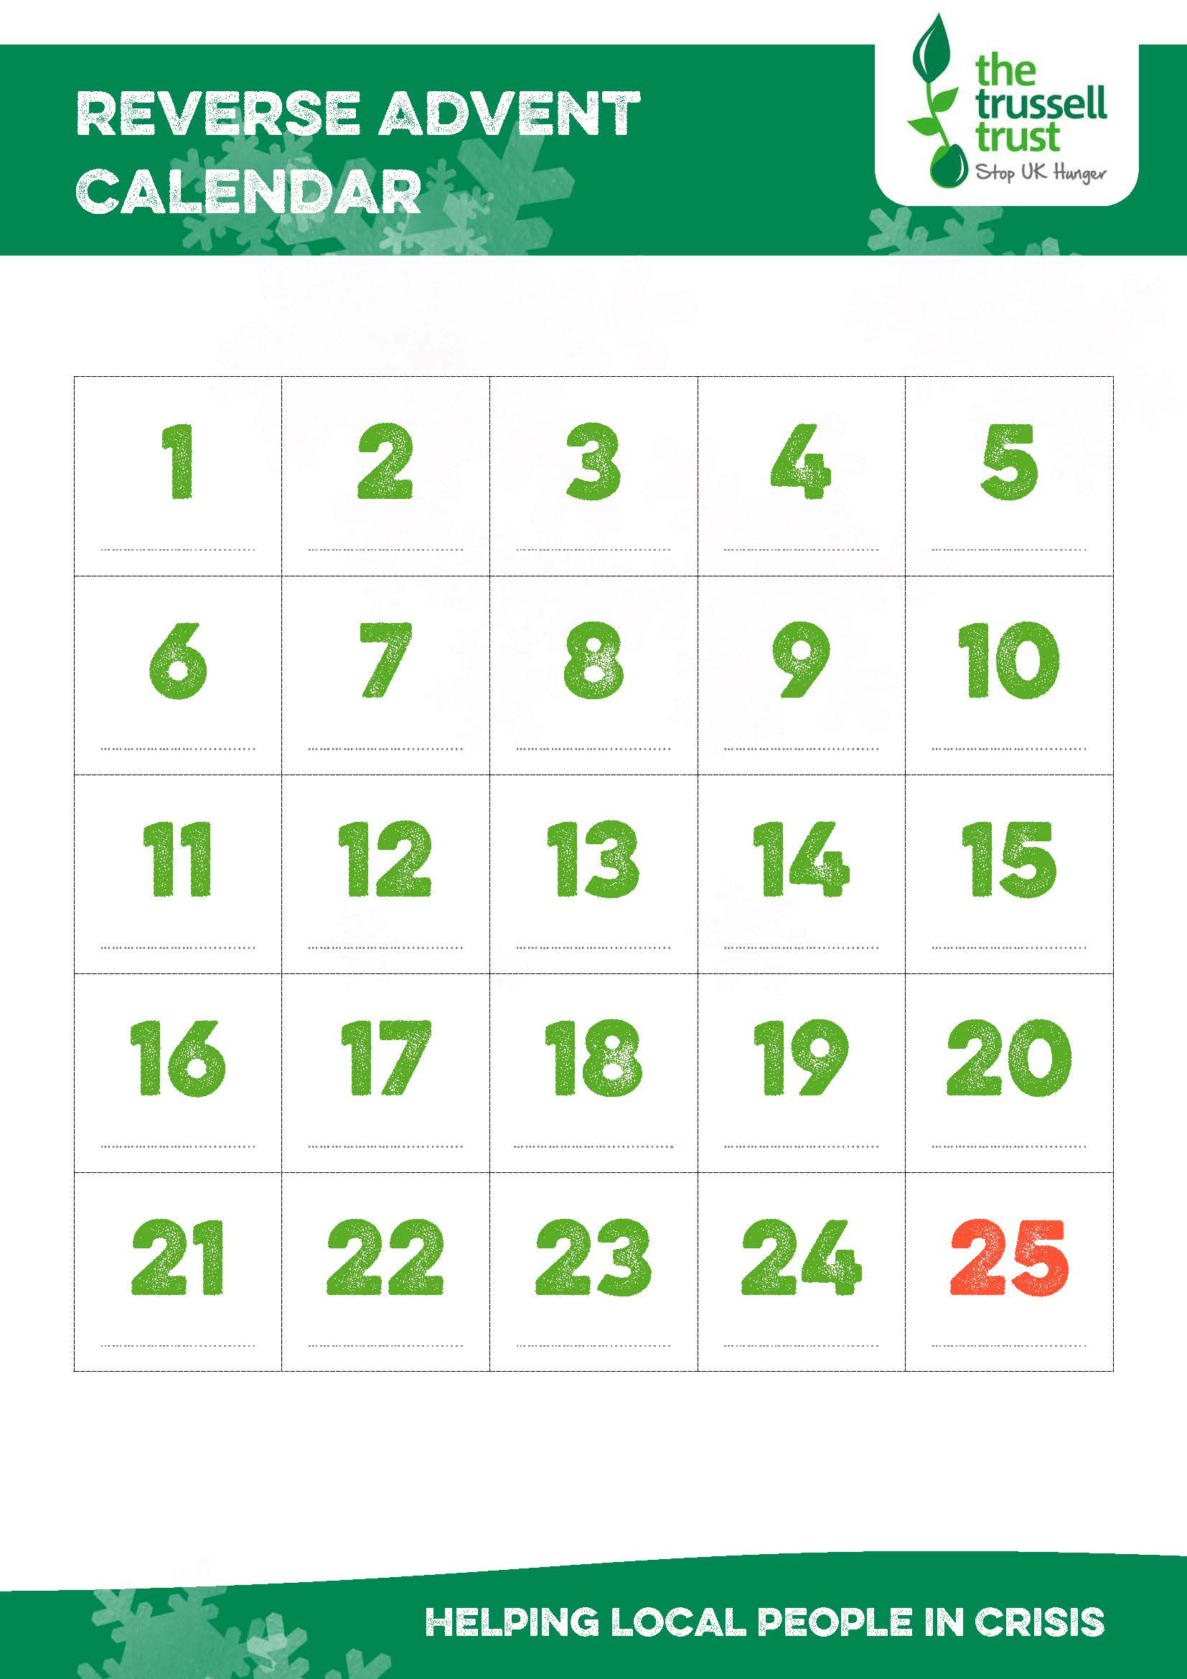

**Jar of Coffee 100g**

**Washing Powder (10 washes)**

**Squash 1 Litre**

Pasta Snacks

**Instant Hot Chocolate**

**Sponge Pudding or Cake Bars**

**Tinned Snacks**

**Small Tinned Fruit fruit**

**UHTs**

**Dried Milk**

**Instant Mash Potatoes**

**Small Tinned Meat**

**Large Tinned Meat**

**Happy Christmas**

**Packet Soup**

**Deodorant**

**Simply donate an item for each day of Advent and donate it to the foodbank**

Below is a suggested list of items based on what is needed by Hinckley Area foodbank

**Tins of Tuna**

**Shampoo**

**Noodle Snacks**

**Rice 500g**

**Shaving Foam**

**Large Tinned Veg**

**Jam**

**Tin Openers**

**Biscuits 400g**

**UHT Fruit Juice**

**Supporting Hinckley Area foodbank**

**www.hinckleyarea.foodbank.org.uk**

Reg. Charity No. 1154754- Reg. in England & Wales